# **OPEM Report (Chakraborty Model)**

## **Chakraborty Fuel Cell Model**

The new dynamic model is presented based on constant fuel utilization control (constant stoichiometry condition). The model solves the long-standing problem of mixing reversible and irreversible potentials (equilibrium and non-equilibrium states) in the Nernst voltage expression. Specifically, a Nernstian gain term is introduced for the constant fuel utilization condition, and it is shown that the Nernstian gain is an irreversibility in the computation of the output voltage of the fuel cell.

## **Inputs**

| Input | Description | Value |
| --- | --- | --- |
| E0 | No load voltage [V], Default Value:0.6 | 0.7 |
| KH2 | Hydrogen valve constant [kmol.s^(-1).atm^(-1)] | 0.000843 |
| KH2O | Water valve constant [kmol.s^(-1).atm^(-1)] | 0.000281 |
| KO2 | Oxygen valve constant [kmol.s^(-1).atm^(-1)] | 0.00252 |
| N0 | Number of cells | 236.0 |
| R | Internal ohmic resistance [ohm] (*Optional) | 0.00328125 |
| T | Fuel cell temperature [K] | 1273.0 |
| i-start | Cell operating current start point [A] | 0.1 |
| i-step | Cell operating current step | 0.1 |
| i-stop | Cell operating current end point [A] | 300.0 |
| rho | Hydrogen-Oxygen flow rate | 1.145 |
| u | Fuel utilization ratio | 0.8 |

## **Overall Parameters**

| Parameter | Description | Value |
| --- | --- | --- |
| Efficiency|Pmax | Cell efficiency at maximum power | 0.32644634668332956 |
| Pmax | Maximum power [W] | 26317.398039715805 |
| Ptotal(Elec) | Total electrical power [W] | 50773.40197628418 |
| Ptotal(Thermal) | Total thermal power [W] | 36252.54202371583 |
| VFC|Pmax | Cell voltage at maximum power [V] | 142.71907830648485 |

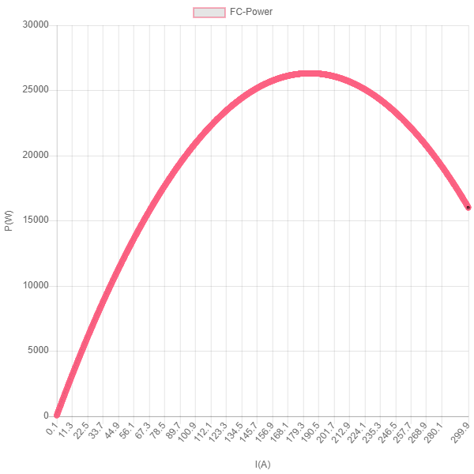

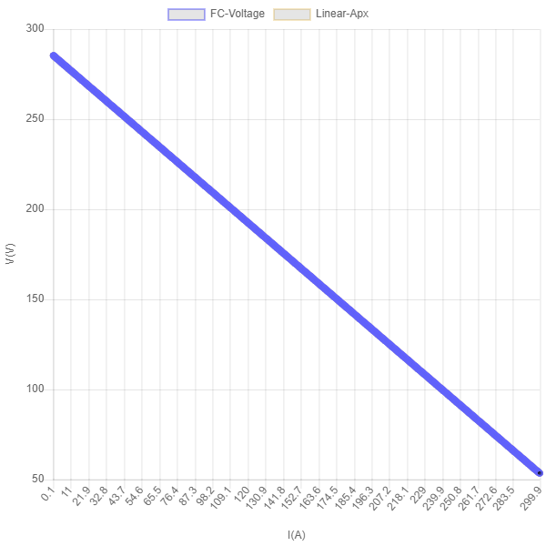

| Parameter | Description | Value |
| --- | --- | --- |
| K | Slope of the curve obtained by linear approximation [A^(-1)] | -0.7743750000000033 |
| Pmax(L-Approx) | Maximum power obtained by linear approximation [W] | 26317.399888369608 |
| V0 | Intercept of the curve obtained by linear approximation [V] | 285.5138283064854 |
| VFC|Pmax(L-Approx) | Cell voltage at maximum power obtained by linear approximation [V] | 142.7569141532427 |

